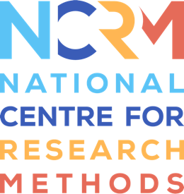
self-portrait and relational map

A step-by-step guide, by Lucy Robinson

Part of resource: https://www.ncrm.ac.uk/resources/online/all/?id=20836

A3 or A4 paper for each participant.
Pencils and pens.
Instructions:
- Begin with the paper in a landscape orientation.
- Ask each participant to draw a self-portrait in the centre of the paper.
- Then, ask the participants to add five key words to describe themselves around their image. These could be identity markers or qualities and characteristics they perceive in themselves, or others perceive in them.
- Now ask the participants to draw three concentric circles around their self-portrait and accompanying words.
- In the inner circle, ask participants to add their responses to the question, Who and/or what is most important to you?
- In the outer circle, ask participants to add their responses to the question, Who and/or what is important to you, but less so?
- Based on what the participants have included, discussion can follow from this.
Top Tips:
- You can create an example, based on yourself, to guide participants with their own work. This can also help develop a rapport and positive relationship with your participants.
- If your participants are hesitant to draw, gentle encouragement and the suggestion of a stick figure could work to allay any concerns.
- You do not have to limit the participants to 5 key words; this is just a suggestion. Your participants may wish to create a ‘word self-portrait' and therefore use more.
Adaptations:
- If your participants have limited manual dexterity, a pre-made template could be used with the central space and concentric circles already drawn out.
- If your participants have developing language skills, the activity can be made visual by asking participants to draw pictures of what is important to them or use pre-existing images. A word-bank of identity markers and qualities/characteristics could also be provided to help scaffold their responses.

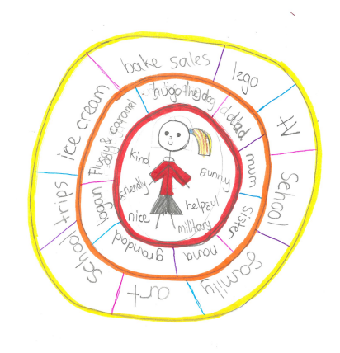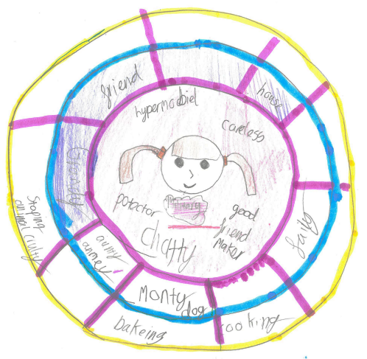
Examples of the ‘self-portrait and relational map’, created by research participants involved in the author’s doctoral research (ongoing).

National Centre for Research Methods (NCRM)
Social Sciences
Murray Building (Bldg 58)
University of Southampton
Southampton SO17 1BJ
United Kingdom
Web www.ncrm.ac.uk
Email info@ncrm.ac.uk
Tel +44 23 8059 4539
Twitter @NCRMUK

